Course: Lines and Angles – A Complete, Concise Study Program
Overview
- Audience: Middle school to early high school; useful for exam prep and foundation for geometry/coordinate geometry.
- Prerequisites: Basic arithmetic, simple algebra (solving linear equations), plotting points on a grid.
- Materials: Ruler/straightedge, protractor, compass, graph paper, calculator (optional), dynamic geometry software (e.g., GeoGebra).
- Outcomes: Define and classify lines and angles; measure and construct angles; prove angle relationships; analyze parallel lines with transversals; compute angles in triangles/polygons; work with line equations, slope, and angles between lines; apply in real contexts (bearings, elevation/depression).

Index Table
Lesson | Title | Key Topics | Outcomes
1 | Points, Lines, Rays, Segments | Definitions, notation, collinear, coplanar | Use correct terms/notation; distinguish line/segment/ray
2 | Types of Lines & Incidence | Parallel, intersecting, perpendicular, skew (intro) | Identify and classify line relationships
3 | Angle Basics & Measurement | Degree measure, protractor use, naming angles | Measure/draw angles; name angles properly
4 | Angle Types | Acute, right, obtuse, straight, reflex, full turn | Classify angles; convert between units
5 | Angle Pairs I | Adjacent, vertical, linear pairs | Solve for unknowns using angle pair facts
6 | Angle Pairs II | Complementary, supplementary, angle chasing | Multi-step problems with algebra
7 | Angle Bisectors | Definition, properties, constructions | Construct and use angle bisectors
8 | Parallel Lines I | Transversals, corresponding/alternate angles | Identify equal/related angles; justify
9 | Parallel Lines II | Co-interior (same-side) angles, proofs | Write short proofs; solve unknown angles
10 | Constructions I | Perpendicular lines, from/to a point | Construct perpendiculars cleanly
11 | Constructions II | Parallels, copying/constructing angles | Draw accurate parallels; copy angles
12 | Triangles & Angles I | Triangle sum, exterior angle theorem | Compute interior/exterior angles
13 | Triangles & Angles II | Isosceles/Equilateral angle properties | Angle chasing in triangles
14 | Polygons & Angles | Interior/exterior sums, regular polygons | Use formulas for n-gons; solve problems
15 | Coordinate Lines I | Slope, intercepts, line forms | Write y=mx+b, point-slope, standard
16 | Coordinate Lines II | Parallel/perpendicular slopes, distance | Parallel/perpendicular tests; distance to line
17 | Angle Between Lines | Formula with slopes; to axes; bearings/elevation | Compute angle between lines; apply
18 | Reasoning & Proof | Two-column/flow proofs with lines/angles | Construct clear logical proofs
19 | Mixed Review A | Integrated practice (Euclidean) | Fluency in pure geometry problems
20 | Mixed Review B | Integrated practice (Coordinate/applications) | Fluency in coordinate/app problems
21 | Assessment | Quiz + project + final test | Demonstrate mastery

Module 1: Foundations
- Points, Lines, Rays, Segments
- Objectives:
  - Define and use: point, line, line segment, ray.
  - Recognize collinear and coplanar sets; use geometric notation.
- Key Ideas:
  - A line has infinite length, no thickness; a segment has endpoints; a ray has one endpoint.
  - Notation: line AB as $\overset{↔}{AB}$, segment AB as $\overset{‾}{AB}$, ray AB as $\vec{AB}$.
- Worked Example:
  - Name all rays from point A in triangle ABC: $\vec{AB}$, $\vec{AC}$.
- Practice:
  - Identify: Is $\overset{‾}{PQ}$ a line, segment, or ray? (Segment)
  - How many points determine a unique line? (Two)
  - True/False: Three noncollinear points determine a plane. (True)
- Quick Check: List two ways to name line through points M and N. (Line MN; $\overset{↔}{MN}$)
Element | Definition from Course | Properties | Notation
Line | A straight path that extends infinitely in both directions. | Has no endpoints and infinite length. | Line AB or $\overleftrightarrow{AB}$
Ray | A part of a line that starts at one point and extends infinitely in one direction. | Has one endpoint (starting point). | Ray AB or $\vec{AB}$
Line Segment | A part of a line with two distinct endpoints. | Has finite length. | Segment AB or $\overline{AB}$

- Types of Lines & Incidence
- Objectives:
  - Classify line relationships: parallel, intersecting, perpendicular.
  - Understand skew lines (informal intro in 3D).
- Key Ideas:
  - Parallel: never meet, same plane. Perpendicular: intersect at ${90}^{∘}$.
- Worked Example:
  - If line a ⟂ line b and line b ∥ line c, is line a ⟂ line c? (Yes, in the same plane.)
- Practice:
  - Draw two parallel lines and one transversal.
  - Give a real-life example of parallel and perpendicular lines. (Rail tracks; corners of paper)
  - Are skew lines possible in a plane? (No)
Ray
Point
Line Segment

Line

Module 2: Angles
- Angle Basics & Measurement
- Objectives:
  - Define angle as rotation between two rays; vertex notation.
  - Measure/draw with a protractor to nearest degree.
- Key Ideas:
  - Naming angles: $∠ABC$ with B as vertex; arcs denote size.
- Worked Example:
  - Draw $∠{47}^{∘}$ at point P; label rays.
- Practice:
  - Measure a given drawn angle (student exercise).
  - What is the measure of a straight angle? (180°)
  - Convert 0.5 turn to degrees. (180°)
- Angle Types
- Objectives:
  - Classify: acute (<90°), right (=90°), obtuse (90–180°), straight (=180°), reflex (180–360°), full turn (=360°).
  - Convert degrees-minutes-seconds if encountered.
- Worked Example:
  - Classify 135°. (Obtuse)
- Practice:
  - 270° is what type? (Reflex)
  - 90° is both right and what else? (Neither acute nor obtuse; special right angle)
  - Which is larger: 100° or 1.6 radians? (1.6 rad ≈ 91.6°, so 100°)
- Angle Pairs I: Adjacent, Vertical, Linear Pairs
- Objectives:
  - Use definitions to find unknown angles.
  - Apply vertical angles are equal; linear pair sums to 180°.
- Worked Example:
  - Two lines intersect; one angle is $x+{25}^{∘}$, vertical angle is $3x-{35}^{∘}$. Solve: $x+25=3x-35⇒x=30$. Angle measure: ${55}^{∘}$.
- Practice:
  - Linear pair: $3y+10$ and $5y-2$. Find y and both angles. (y=21; 73°, 107°)
  - Vertical angles: $2a+14$ and $5a-19$. (a=11; angles 36°)
  - Adjacent angles sum to 120°; one is twice the other. Find both. (40°, 80°)
- Angle Pairs II: Complementary, Supplementary; Angle Chasing
- Objectives:
  - Complementary sum to 90°, supplementary sum to 180°.
  - Multi-step algebraic angle chasing.
- Worked Example:
  - If $∠A$ and $∠B$ are supplementary, $∠A=2∠B$. Then $2B+B=180⇒B={60}^{∘},A={120}^{∘}$.
- Practice:
  - Complementary: $x+15$ and $2x-3$. (x=26; 41°, 49°)
  - Three angles around a point: $x,2x,3x$. Find x. (x=60°)
  - Around a point with one right angle and two equal angles; find each equal angle. (45°)
- Angle Bisectors
- Objectives:
  - Define/construct an angle bisector.
  - Use: points on bisector are equidistant from sides.
- Construction (compass/straightedge):
  - From vertex, mark arcs on both sides; with those as centers, intersecting arcs inside; join vertex to intersection.
- Worked Example:
  - Bisect ${76}^{∘}$: result ${38}^{∘}$.
- Practice:
  - If ray BX bisects $∠ABC={64}^{∘}$, find $∠ABX$. (32°)
  - In $∠P$, PX is bisector; point Q on PX. What is $d(Q,$ sides of $\left.∠P\right)$? (Equal)
  - Construct and verify with a protractor.
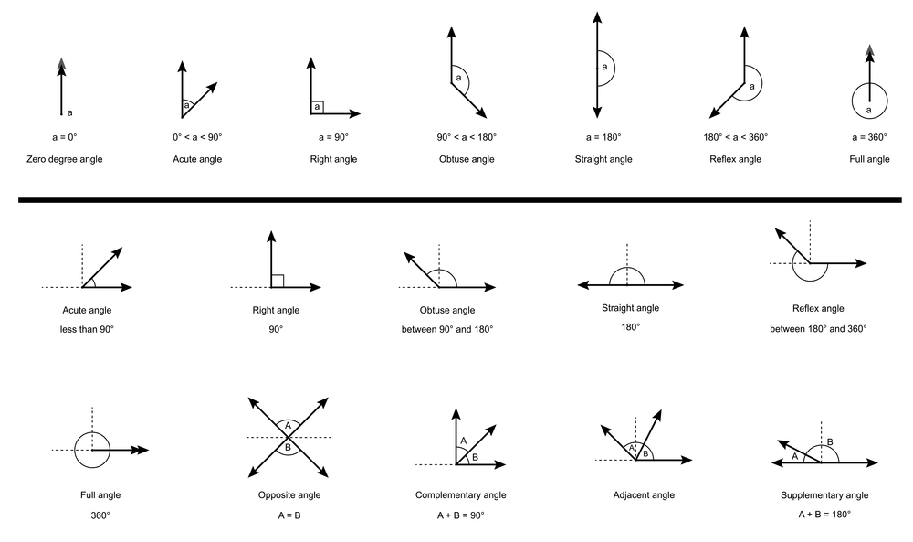

Module 3: Parallel Lines and Transversals
- Parallel Lines I: Corresponding and Alternate Angles
- Objectives:
  - Identify corresponding, alternate interior/exterior angles.
  - Use corresponding and alternate interior angle theorems (if lines ∥).
- Key Facts:
  - If lines are parallel, corresponding angles are equal; alternate interior angles are equal.
- Worked Example:
  - Given $∠1={68}^{∘}$ (corresponding to $∠5$), find $∠5$ if lines ∥: ${68}^{∘}$.
- Practice:
  - Find all eight angles formed by two ∥ lines cut by a transversal given one is 120°. (120°, 60° pattern)
  - Prove in one step: If corresponding angles are equal, lines are ∥. (Converse theorem)
  - If $∠a=3x+6$ and its alternate interior mate is $5x-18$, find x. (x=12)
- Parallel Lines II: Co-interior Angles and Proofs
- Objectives:
  - Same-side interior angles are supplementary.
  - Write brief proofs using angle relationships.
- Worked Example (Proof sketch):
  - Show interior angles on same side sum to 180° using a straight line and alternate interior angle equality.
- Practice:
  - Co-interior: $2y+10$ and $4y-2$ sum to 180. Find y. (y=28)
  - Prove: If a transversal is perpendicular to one of two ∥ lines, it is perpendicular to the other.
  - Determine if lines are ∥ from a diagram given angle measures (justify).
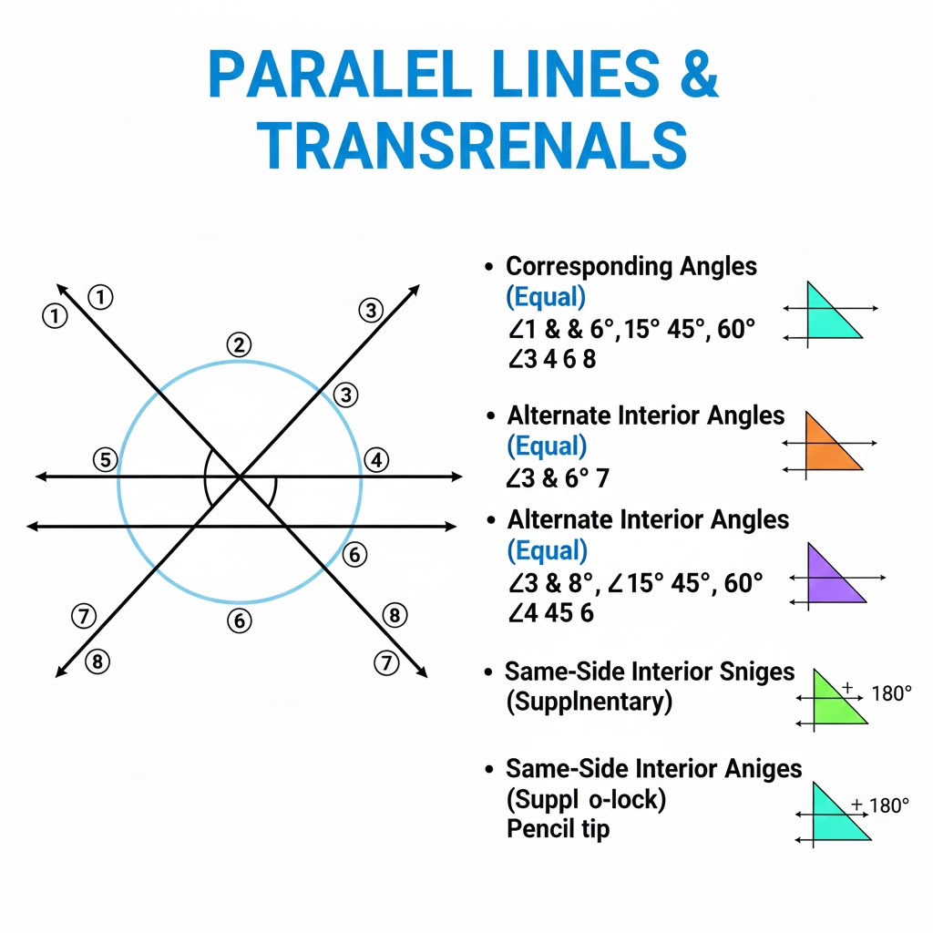

Module 4: Constructions
- Constructions I: Perpendiculars
- Objectives:
  - Construct a perpendicular through a point on a line and from a point to a line.
- Steps (from a point to a line):
  - With the point as center, cut the line at two points; from those points draw arcs intersecting; join the point to intersection.
- Practice:
  - Construct altitude from a point to a line; verify 90°.
  - Midpoint via perpendicular bisector of a segment.
  - Explain why perpendicular bisector locates all points equidistant from endpoints.
- Constructions II: Parallels and Copying Angles
- Objectives:
  - Draw a line through a point parallel to a given line.
  - Copy and construct a given angle.
- Steps (parallel via corresponding angles):
  - Through the point, replicate the angle made by the transversal using compass; draw line through the point.
- Practice:
  - Construct parallel through an external point; check with protractor.
  - Copy a ${53}^{∘}$ angle without a protractor.
  - Bisect a given angle and discuss accuracy.

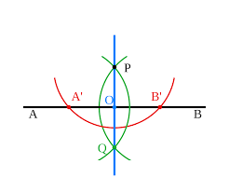

Module 5: Triangles and Angle Chasing
- Triangles & Angles I: Sum and Exterior Angle Theorem
- Objectives:
  - Triangle interior angles sum to ${180}^{∘}$.
  - Exterior angle equals sum of remote interior angles.
- Worked Example:
  - Triangle ABC with angles $x,2x,3x$: $x+2x+3x=180⇒x={30}^{∘}$.
- Practice:
  - Exterior angle is 125°; one remote is 35°. Find the other. (90°)
  - Triangle with angles $2y+10,y+20,3y-10$. Find y. (y=20)
  - Right triangle with one acute ${37}^{∘}$. Find the other acute. (53°)
- Triangles & Angles II: Isosceles/Equilateral Properties
- Objectives:
  - Isosceles: base angles equal; Equilateral: all 60°.
  - Use angle bisector properties in triangles.
- Worked Example:
  - Isosceles with vertex angle 34°; base angles ${73}^{∘}$ each.
- Practice:
  - Triangle with sides AB=AC. At A, angle split by bisector; find base angles if one piece is ${20}^{∘}$. (Each base = 70°)
  - Equilateral triangle external angle. (120°)
  - Prove: If two angles are equal, opposite sides are equal.
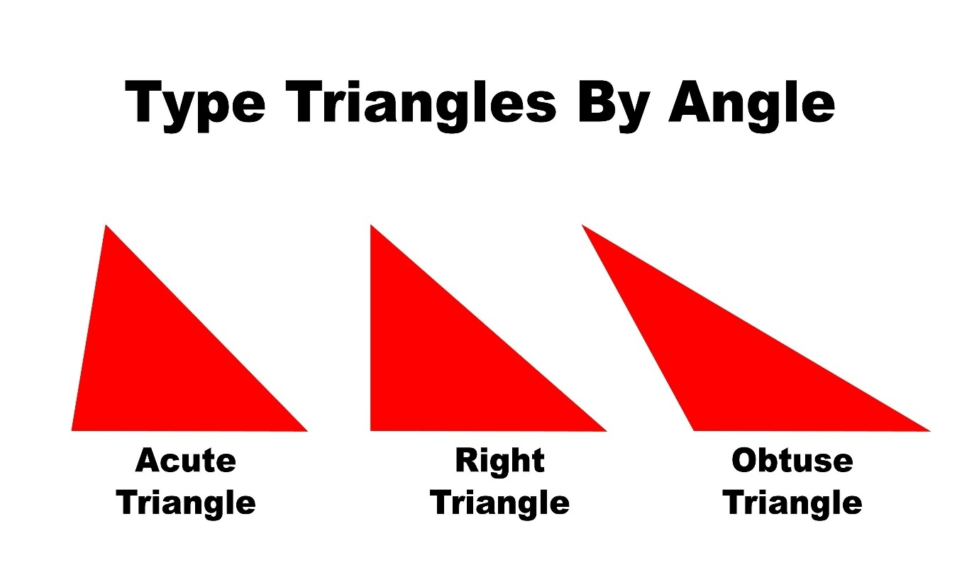

Module 6: Polygons
- Polygons & Angles
- Objectives:
  - Interior sum: $(n-2)×{180}^{∘}$.
  - Exterior sum (one at each vertex): ${360}^{∘}$.
  - Regular polygon interior/exterior angle measures.
- Worked Examples:
  - Regular nonagon: interior $={140}^{∘}$, exterior $={40}^{∘}$.
  - Given interior $={162}^{∘}$, find n: $180-162=18⇒n=360/18=20$.
- Practice:
  - Sum of interior angles for a 15-gon. (2340°)
  - Regular polygon with exterior ${24}^{∘}$; find n. (15)
  - Find a missing interior angle in an irregular quadrilateral given three others.

Module 7: Coordinate Geometry of Lines
- Coordinate Lines I: Slope and Equations
- Objectives:
  - Slope $m=\frac{Δy}{Δx}$; intercepts.
  - Equation forms: slope-intercept $y=mx+b$, point-slope $y-y_{1}=m(x-x_{1})$, standard $Ax+By=C$.
- Worked Example:
  - Through (2,−1) and (5,5): $m=\frac{6}{3}=2$. Equation: $y+1=2(x-2)⇒y=2x-5$.
- Practice:
  - Find slope: (−3,4) to (1,−8). (m=−3)
  - Line with m=−1/2 through (0,7). (y=−(1/2)x+7)
  - Convert $3x-2y=8$ to slope-intercept. (y=(3/2)x−4)
- Coordinate Lines II: Parallel/Perpendicular; Distances
- Objectives:
  - Parallel: same slope; Perpendicular: $m_{1}m_{2}=-1$.
  - Distance from point to line.
- Key Formulas:
  - Distance point $\left(x_{0} , y_{0}\right)$ to line $Ax+By+C=0$: $\frac{∣Ax_{0}+By_{0}+C∣}{\sqrt{A^{2}+B^{2}}}$.
- Worked Example:
  - Line through (3,2) perpendicular to $2x+4y-7=0$: slope original $m=-A/B=-2/4=-1/2$; perpendicular slope $=2$. Equation: $y-2=2(x-3)⇒y=2x-4$.
- Practice:
  - Are $y=3x+1$ and $3y=x-2$ perpendicular? (m1=3, m2=1/3 ⇒ product=1, so No)
  - Distance from (−1,4) to $x-2y+2=0$. (|−1−8+2|/√5=|−7|/√5=7/√5)
  - Line through (−2,5) parallel to $4x-3y=12$. (y=(4/3)x+ b; plug to find b= (4/3)(−2) + b =5 ⇒ b= 5+8/3=23/3)
- Angle Between Lines; Bearings/Elevation
- Objectives:
  - Angle between lines slopes $m_{1},m_{2}$: $tan⁡θ=∣\frac{m_{2}-m_{1}}{1+m_{1}m_{2}}∣$.
  - Angle to axes; bearings; elevation/depression.
- Worked Examples:
  - Angle between $y=2x$ and $y=-\frac{1}{2}x$: $m_{1}=2,m_{2}=-1/2⇒1+m_{1}m_{2}=0⇒θ={90}^{∘}$.
  - Bearing: N 40° E means rotate 40° toward east from north.
- Practice:
  - Between $y=x$ and $y=3x$. ($tan⁡θ=∣3-1∣/(1+3)=0.5⇒θ≈{26.565}^{∘}$)
  - Angle a line $y=-2x+1$ makes with positive x-axis. ($tan⁡α=∣-2∣⇒α≈{63.435}^{∘}$)
  - A hill rises at 12° over horizontal; height after 200 m along slope? (h=200·sin12°≈41.6 m)
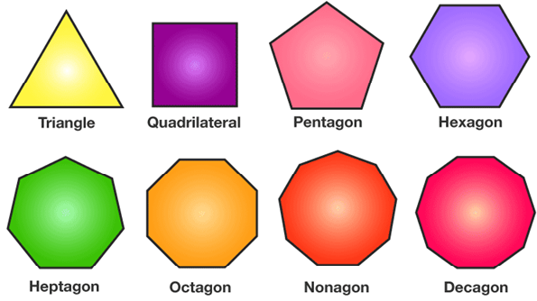

Module 8: Reasoning, Proof, and Mixed Practice
- Reasoning & Proof with Lines and Angles
- Objectives:
  - Build two-column/flow/paragraph proofs using angle theorems.
  - Use converses (e.g., corresponding angles equal ⇒ lines ∥).
- Sample Proof Skeleton:
  - Given: Two lines cut by a transversal with a pair of equal alternate interior angles.
  - Prove: Lines are parallel.
  - Reasoning: If alternate interior angles are equal, by converse theorem, lines are ∥.
- Practice:
  - Prove vertical angles are equal using linear pairs.
  - Prove exterior angle theorem from parallel line through vertex.
  - Write a paragraph proof: If a transversal is perpendicular to one of two ∥ lines, it is perpendicular to the other.
- Mixed Review A (Euclidean)
- Focus:
  - Multi-step angle chasing with parallel lines and triangles.
  - Polygon interior/exterior problems.
- Practice Set (selected):
  - Two ∥ lines; transversal creates angles with measures $x+20$ and $3x-40$ as co-interior. Find both. (x=100; 120° and 60°)
  - In triangle ABC, external at C is 125°, internal at A is 45°. Find B. (B=80°)
  - Find each interior angle of a regular 18-gon. (160°)
- Mixed Review B (Coordinate & Applications)
- Focus:
  - Slopes, distances, and angles between lines.
  - Bearings/elevation word problems.
- Practice Set (selected):
  - Find angle between lines $2x-y+1=0$ and $x+2y-7=0$. (m1=2, m2=−1/2 ⇒ 90°)
  - Shortest distance from (5,−3) to $3x+4y+12=0$. (|15−12+12|/5=15/5=3)
  - A ship sails with bearing 120° for 10 km, then 210° for 10 km. Find net displacement magnitude and direction (vector addition; approximate).
- Assessment: Quiz, Project, Final Test
- Quiz (20–25 min): Quick computations on angle pairs, parallel lines, triangle sums, slope checks.
- Project (Individual or Pair):
  - “City Grid Design”: Create a street map imposing parallel/perpendicular constraints, include bearings between landmarks; justify with short proofs.
- Final Test (60 min):
  - Sections: Definitions/MCQ (20%), Constructions/Methods (10%), Short proofs (30%), Computation (25%), Applications (15%).

Key Formulas and Facts Sheet
- Angle Types: acute (<90°), right (=90°), obtuse (90–180°), straight (=180°), reflex (180–360°).
- Angle Pairs: vertical angles equal; linear pair sums to 180°; complementary sum 90°; supplementary sum 180°.
- Parallel Lines and Transversal:
  - Corresponding angles equal; alternate interior/exterior equal; co-interior sum 180°.
  - Converse statements determine parallelism.
- Triangle Angles: interior sum 180°; exterior equals sum of two remote interior.
- Polygon Angles: interior sum $(n-2)×{180}^{∘}$; each interior (regular) $=\frac{(n-2){180}^{∘}}{n}$; each exterior (regular) $=\frac{{360}^{∘}}{n}$.
- Slope: $m=\frac{Δy}{Δx}$.
- Line Forms: $y=mx+b$; $y-y_{1}=m(x-x_{1})$; $Ax+By=C$.
- Parallel/Perpendicular Slopes: equal slopes ⇒ parallel; $m_{1}m_{2}=-1$ ⇒ perpendicular.
- Distance from point to line $Ax+By+C=0$: $\frac{∣Ax_{0}+By_{0}+C∣}{\sqrt{A^{2}+B^{2}}}$.
- Angle between lines (slopes $m_{1},m_{2}$): $tan⁡θ=∣\frac{m_{2}-m_{1}}{1+m_{1}m_{2}}∣$.

Common Misconceptions to Watch 1)using vertical with adjacent angles. 2) Assuming all corresponding angles are equal without verifying lines are parallel. 3) Mixing up interior vs exterior angles of polygons. 4) Thinking perpendicular slopes are negative reciprocals even when one is vertical/undefined (handle special cases carefully). 5) Misreading bearings (clockwise from north) vs standard math angles (counterclockwise from positive x-axis).

Suggested Pacing ()
- 3–4 weeks at 5 lessons/week, 45–60 minutes each.
- Include warm-ups (5 min), mini-lesson (15–20), guided practice (15), quick check (5), and exit ticket.

Answer Keys (Selected)
- Lesson 5: (1) y=21; 73°, 107° (2) a=11; 36° (3) 40°, 80°
- Lesson 6: (1) x=26; 41°, 49° (2) 60° (3) 45°
- Lesson 8: (3) x=12
- Lesson 9: (1) y=28
- Lesson 12: (1) 90° (2) y=20 (3) 53°
- Lesson 13: (1) 70° each base (2) 120°
- Lesson 14: (1) 2340° (2) 15
- Lesson 15: (1) −3 (2) y=−(1/2)x+7 (3) y=(3/2)x−4
- Lesson 16: (1) No (2) $7/\sqrt{5}$ (3) $y=(4/3)x+23/3$
- Lesson 17: (1) ≈26.565° (2) ≈63.435° (3) ≈41.6 m
- Review A: (1) 120°, 60° (2) 80° (3) 160°
- Review B: (1) 90° (2) 3

